 | 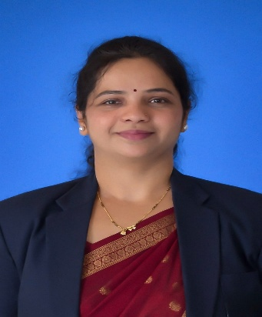 |  |  |  | Mrs. Dhanashri Devendra Dhokate  Assistant Professor | Computer Science and Engineering  P. V. P. Institute of Technology, Budhgaon
 | Objectives  "Leveraging my experience in CSE, I am dedicated to empowering students and utilizing my technical leadership to help the institution reach new heights of excellence."  Expertise  - Operating System  - Computer Networks  - Database Engineering  - Machine Learning  Competency  - Highly interested in IPR and Design Thinking  - Good in leadership team work  - Good in Student Counseling  - Special Involvement in student Projects and innovation.  IPR  Patents: 6  Book: 1  Papers/Publications  - International Journals: 16  - National Conferences: 02  STTPs/FDPs  - Two Week : 13  - One Week : 22  Project Guided  - UG: 55 +  - PG: __ |  |  |  | Experience: 20 Years  Assistant Professor Computer Science and Engineering • PVPIT Budhgaon  Today  - Dept Responsibility 1- Head of Department (From 2023 to till date)  - Dept Responsibility 2- Next to Head of Department (2009-2023)  - Dept Responsibility 3- Departmental NAAC Coordinator  - Dept Responsibility 4- III Coordinator  - Dept Responsibility 5- Admission Coordinator  - Dept Responsibility 6- Departmental Project In charge  Education:  Ph. D. •(Pursuing)• Sanjay Ghodawat University  Successfully earned Ph. D. in Computer Science and Engineering at Sanjay Ghemawat University, from Kolhapur Research Center.  M. E. / M. Tech. • July 2015 • DYPCET  Earned the Master’s Degree in Computer Science and Engineering from DYPCET, Kolhapur with first class.  B. E. / B. Tech • July 2005 • WCE, Sangli  Earned the Bachelor’s Degree in Computer Science and Engineering from WCE, Sangli with First Class.  Engineering Diploma • ICRE Gargoti  Earned the Engineering Diploma Degree in Computer Engineering from ICRE, Gargoti with Distinction  Other Responsibilities:  - Head of Department  - IIC Convener  - FC Coordinator  - CAP QC Coordinator  - Central NAAC Criteria Co-ordinator  - R&D Committee member  - RR Committee member  - Sr. Supervisor  - QPD Coordinator  - Admission and FC coordinator
dddhokate,cse@pvpitsangli.edu.in |  | 9764276581 |  |  |  | https://www.linkedin.com/in/mrs-d-d-dhokate-7361812b5/

