 | 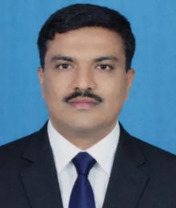 |  |  |  | Mr. Amol B.Jagadale.  Assistant Professor | in Computer Science and Engineering  P. V. P. Institute of Technology, Budhgaon
 | Objectives  To excel in teaching, research, and mentorship while achieving continuous academic growth and contributing to institutional and student development.  Expertise  - Embedded Controls and VLSI  - Electronic System design  - Computer Architectures  Competency  - Team management  - Collaborative execution  - Critical task management  - Establishment  - Resource handling  Papers/Publications  - National Conferences: 11  FDPs  - One Week : 07  Project Guided  - UG: 47  - PG: 10 |  |  |  | Experience: 26 Years  Assistant Professor •Computer science and Engineering • PVPIT Budhgaon  05/03/2025– Till Today  - Assistant Examination controller  - Training and Placement Coordinator  - Senior Supervisor  - Guest lecture Coordinator  - Industry Visit Coordinator  Worked As:  HOD information technology SVERI college of Engineering Pandharpur  HOD Information Technology RMCTE Devrukh  HOD E&TC SKNSCOE korti Pandharpur  Head of Disha Academy Baramati  Head of Apex Academy Vita  Education:  PhD (Perusing) Image Processing SSPU JSPM  M. Tech E&TC • May 2009 • Dr.BATU Lonere Mahad  B. E. Electronics May 1999• PVPIT Budhgaon  GATE 2012  CDAC VLSI Benglore 2001  MPSE 2010 Grade A  Other Responsibilities:  - Vasant Karandak Event - Coordinator for Passion for Poetry  - Vasantotsav 2k26 – Member of Refreshment committee  - Admission Process Counseling and document Verification
amoljagadale.cse@pvpitsangli.edu.in |  | 8080350613 |  |  |  | -

