 | 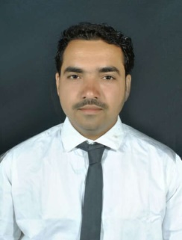 |  |  |  | Mr. Vikas Anna Mali  Assistant Professor |_ ECS Engineering  P. V. P. Institute of Technology, Budhgaon
 | Objectives  Accomplished educator and electronics professional looking to a transition into departmental leadership role.  Expertise  - Electronics engineer  - Software test engineer  Competency  - Electronics devices repairing  - Electronics home appliances repairing  IPR  Patents: ___  Copyright: ____  Papers/Publications  - International Journals: 2  STTPs/FDPs  - One Week : 4  Project Guided  - UG: 3 |  |  |  | Experience: 2 Years  Assistant Professor •Electronics Engineering • PVPIT Budhgaon  01/08/2024– Till Today  - Dept Responsibility  - B Tech class Teacher  - Remuneration Responsibility  Education:  M. Tech. • August 2022 • WCE,Sangli  Earned the Master’s Degree in Electronics from WCE Sangli College with first class.  B. E. • July 2020 • PVPIT  Earned the Bachelor’s Degree in Electronics from PVPIT Budhgaon, Sangli with first class .  Other Responsibilities:  - College Bus coordinator  - External exam supervisor  - Vasant utsav –Discipline committee  - Vasant karandak – Event management committee  - Student Activity Coordinator/Association in charge  - Sports Coordinator
Vikasmali.ecs@pvpitsangli.edu.in |  | +91 9503373965 |  |  |  | Linked in Profile link

