 | 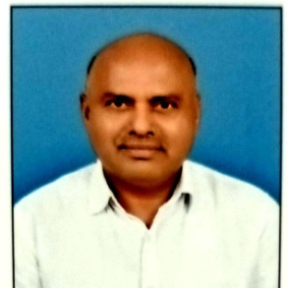 |  |  |  | Dr.Kiransing Pratapsing Paradeshi  Professor in Electronics and Computer Science Engineering  P. V. P. Institute of Technology, Budhgaon
 | Objectives  To contribute my extensive experience through quality teaching, research and student mentoring for their academic leadership and Professional success  Expertise  - Signal Processing  - Control Systems  - Computer Networks  Competency  - Signals and Systems  - Digital Signal Processing  - Control systems  - Python Programming  - Computer Networks  IPR  Patents: 1 utility Patient filed  Papers/Publications  - International Journals:40  - National Conferences:15  - STTPs/FDPs  - Two Week:30  - One Week:25  Project Guided  - UG: 100  - PG: 30 |  |  |  | Experience: 35 Years  Professor •Electronics and computer science Engineering • PVPIT Budhgaon  2021 onwards – Till Today  Associate Professor •Electronics Engineering • PVPIT Budhgaon  2012– 2021  Associate Professor •Electronics Engineering • ADCET, Ashta  2009– 2012  Associate Professor •Electronics Engineering • Bharatratna Indira Gandhi college of Engineering, Solapur  2008– 2009  Sr Lecturer •Electronics Engineering • PVPIT, Budhgaon  1999– 2008  Lecturer •Electronics Engineering • PVPIT, Budhgaon  1991– 1991  Education:  Ph.D. • 2020• Rashtrasant Tukadoji Maharaj Nagpur University, Nagpur  Successfully completed Ph.D. in Electronics Engineering at Rashtrasant Tukadoji Maharaj Nagpur University, Nagpur.  M. E. / M. Tech. • July 2003 • Walchand college of Engineering, Sangli  Master’s Degree In Electronics Engineering from Walchand college of Engineering, Sangli  B. E. / B. Tech • July 1990• PVPIT, Budhgaon  Bachelor’s Degree In Electronics from PVPIT Budhgaon, Sangli  Other Responsibilities:  - Life Member ISTE, New Delhi  - Member of Institution of Engineers  - BOS member ,Electronics and Computer science department, PVPIT  - Special invitee IQAC cell, JJMCOE, Jaysingpur  - Reviewer of Many International Conferences
kpparadeshi.eln@pvpitsangli.edu.in |  | +91 8669018860 |  |  |  | LinkedIN URL

