 | 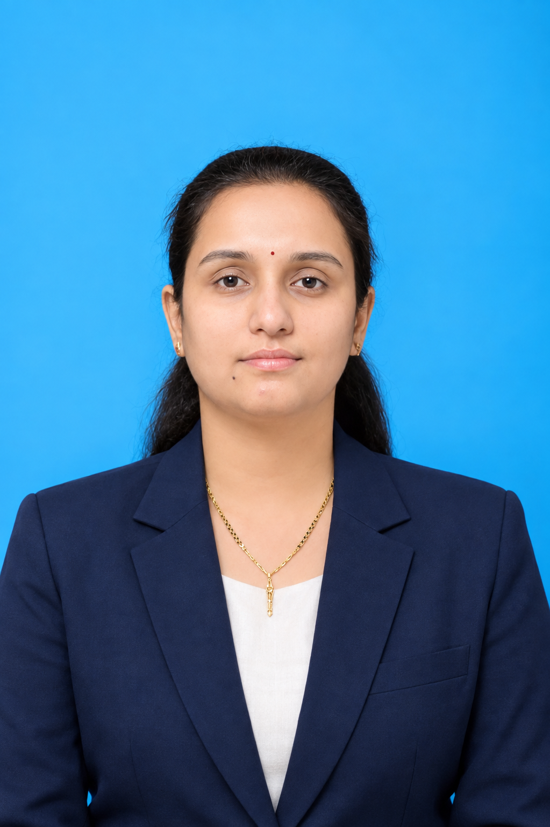 |  |  |  | Ms. Pallavi Sambhaji Kadam  M.Sc. SET Ph.D. (pursuing)  Assistant Professor | Chemistry  P. V. P. Institute of Technology, Budhgaon
 | Objectives  To contribute to the academic and research excellence of the institution through effective teaching, innovative chemistry education, and impactful research in the field of catalysis and sustainable chemical synthesis. I aim to foster a student-centered learning environment, mentor students in academic and research activities, and contribute to the development of the institution through collaborative research, innovation, and continuous professional growth.  Expertise  - Catalysis  - Organic Transformations  - Classroom Teaching  Competency  - Effective Classroom Teaching  - Subject Matter Expertise  - Student Mentoring and Counseling  Academic Administration and  IPR  Patents: ___  Copyright: ____  Papers/Publications  - International Journals: 4  - National Conferences: 4  STTPs/FDPs  - Two Week :  - One Week :  Project Guided  - UG:  - PG: |  |  |  | Experience: 5 Years  Assistant Professor • Basic Science Engineering • PVPIT Budhgaon  29/07/2026– Till Today  - Planning and conducting engaging lectures, tutorials, and laboratory practical sessions.  Undertaking examination-related responsibilities, including question paper preparation, examination supervision, and assessment of answer scripts.  Assistant Professor• Chemistry • Shikshanmaharshi Dr. Bapuji Salunkhe College,Miraj 21/07/2015– 15/04/2020  Assistant Professor •Basic Science Engineering • PVPIT Budhgaon  29/07/2026– Till Today  Education:  Ph. D. • Submitted•Shivaji University Kolhapur  Ph.D. Thesis Submitted To Shivaji University, Kolhapur  SET • Aug 2025 • Savitribai Phule Pune University, Pune  M. Sc. (Chemistry) • March 2015 • Dahiwadi College, Dahiwadi  Earned the Master’s Degree in Organic Chemistry from Dhiwadi College with first class.  B. Sc (Chemistry) • July 2013 • PDVP College, Tasgaon  Earned the Bachelor’s Degree in Chemistry from PDVP College Tasgaon, with distinction.  Other Responsibilities:  - Admission counseling and student orientation programs  - Participated in examination duties, paper setting, and evaluation.
abc.def@gmail.com |  | +91 9876543210 |  |  |  | Linked in Profile link

