Event: Expert Talk

Subject:

1) Carrier Opportunities in Instrumentation Engineering (10.30 am to 12.30 pm)

2) Guidance for final year project selection & execution (1.30 pm to 3.00 pm)

Resource Person: Prof. R. S. Patil

Venue: Seminar Hall (ETC)

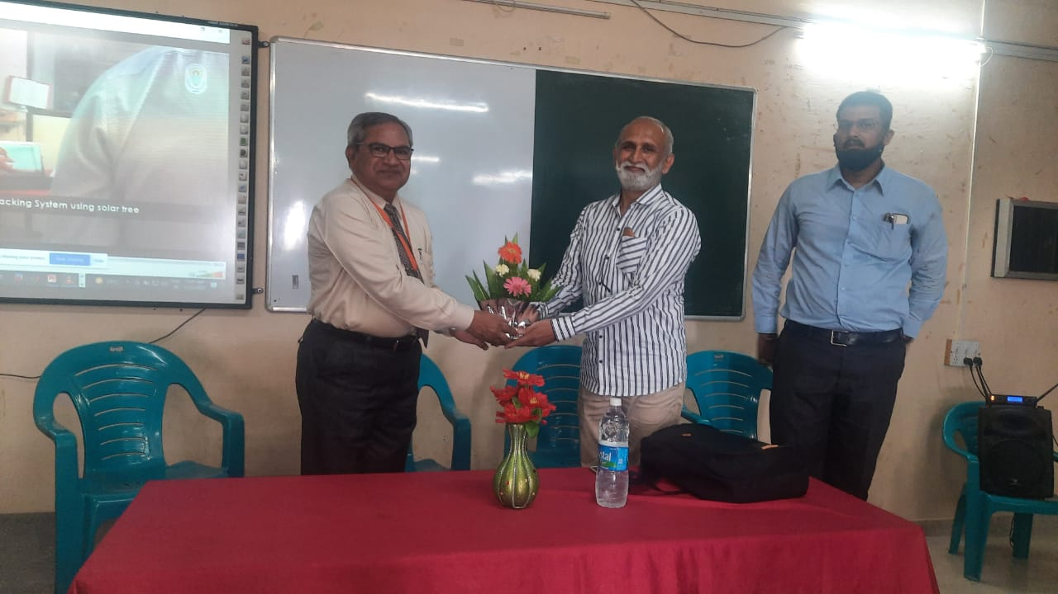

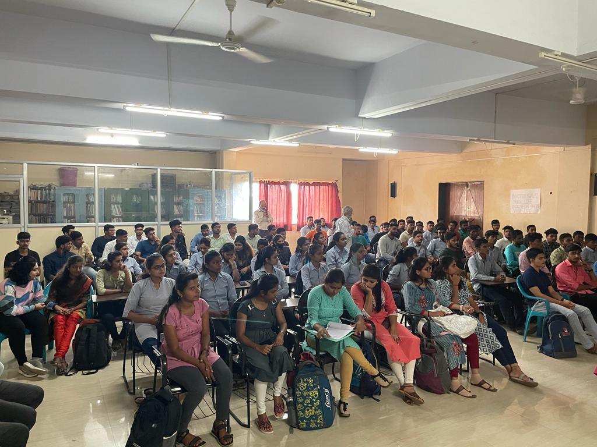

Event: Expert Talk - IOT

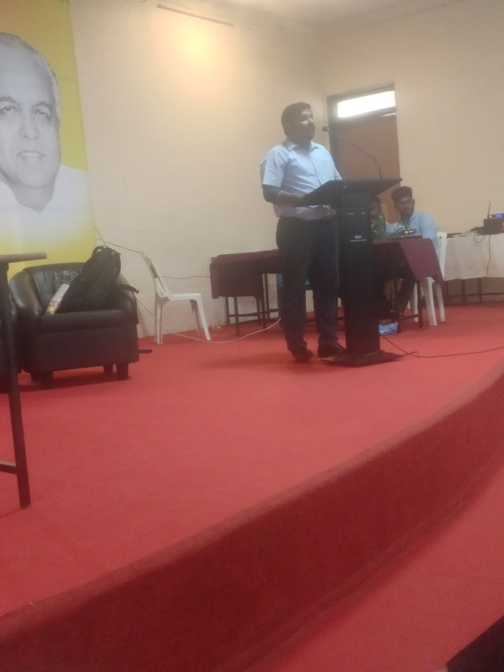

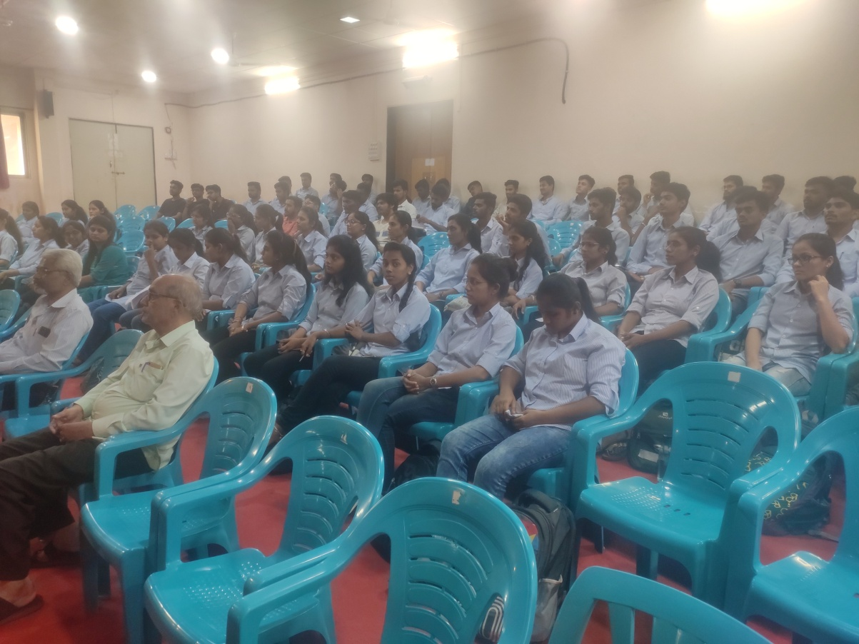

**National Level technical Event- Nirmiti**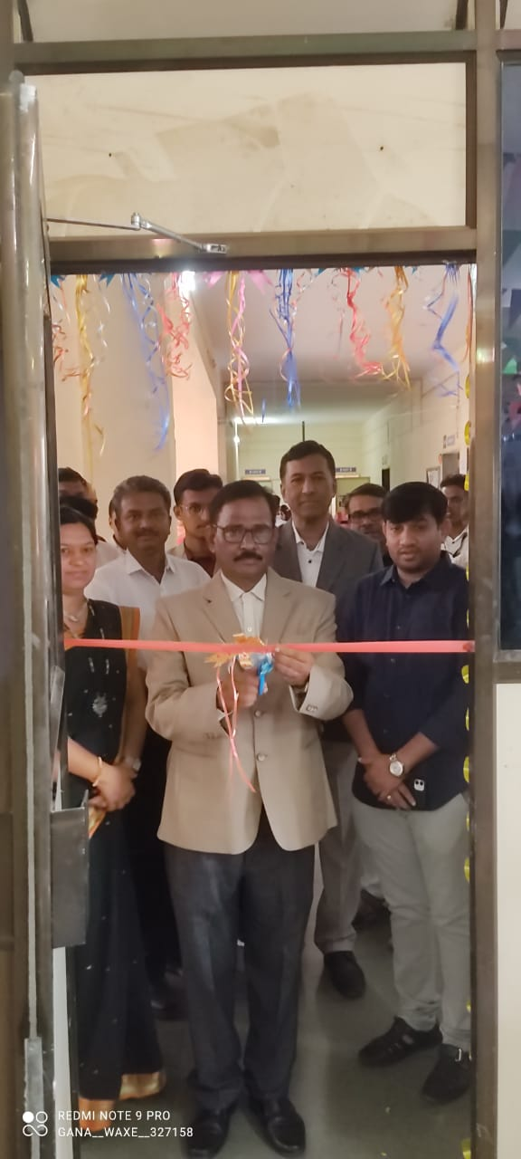

Event: Workshop 15.06.2022

Subject: VLAB

Resource Person: Mr Sudhir Paditrao

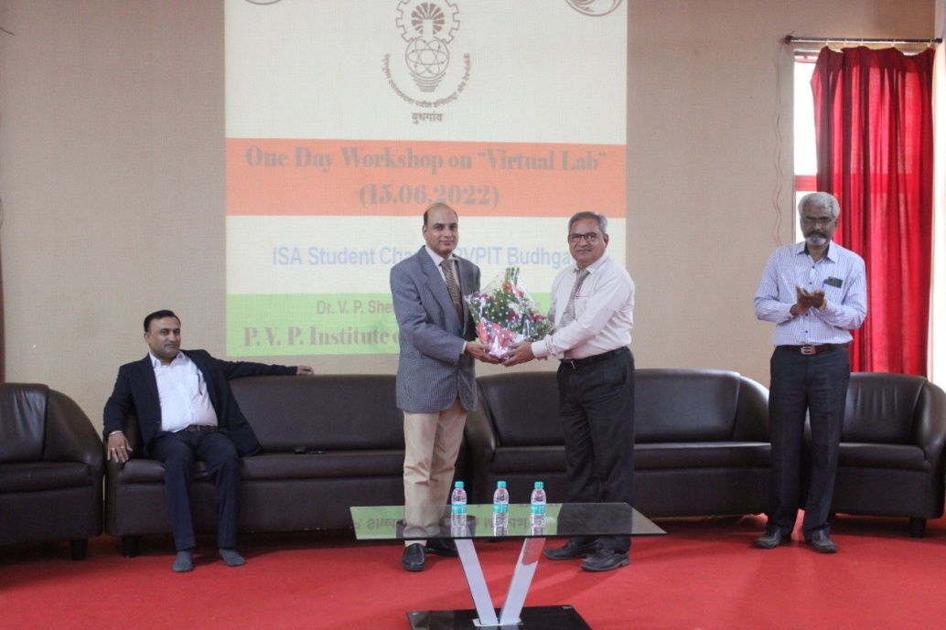

**Activity: One Day Technical Activity ‘Industrial Automation’**

1. Recent trends in Automation
2. Process Instrumentation & Control
3. Role of Sensors & Transducers in Industry

